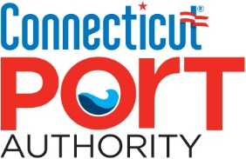

NOTICE OF
REGULAR MEETING OF THE
CONNECTICUT PORT AUTHORITY
FINANCE COMMITTEE

Date: Tuesday, April 18. 2023

Time: 10:00 a.m.

Location: Meeting will be held remotely by conference call

Dial-in Number: (681) 999-0297
PIN: 303243#

AGENDA

- Call to Order

- Approval of March 21, 2023, Finance Committee Meeting Minutes

- Public Comment

- Financial Update

- Discussion of the draft Fiscal Year 2024 Budget

- Consideration and approval of a resolution authorizing the submission of the Fiscal Year 2022 Annual Financial Report pursuant to C.G.S. § 1-123(a).

- Old Business

- New Business

- Adjournment

